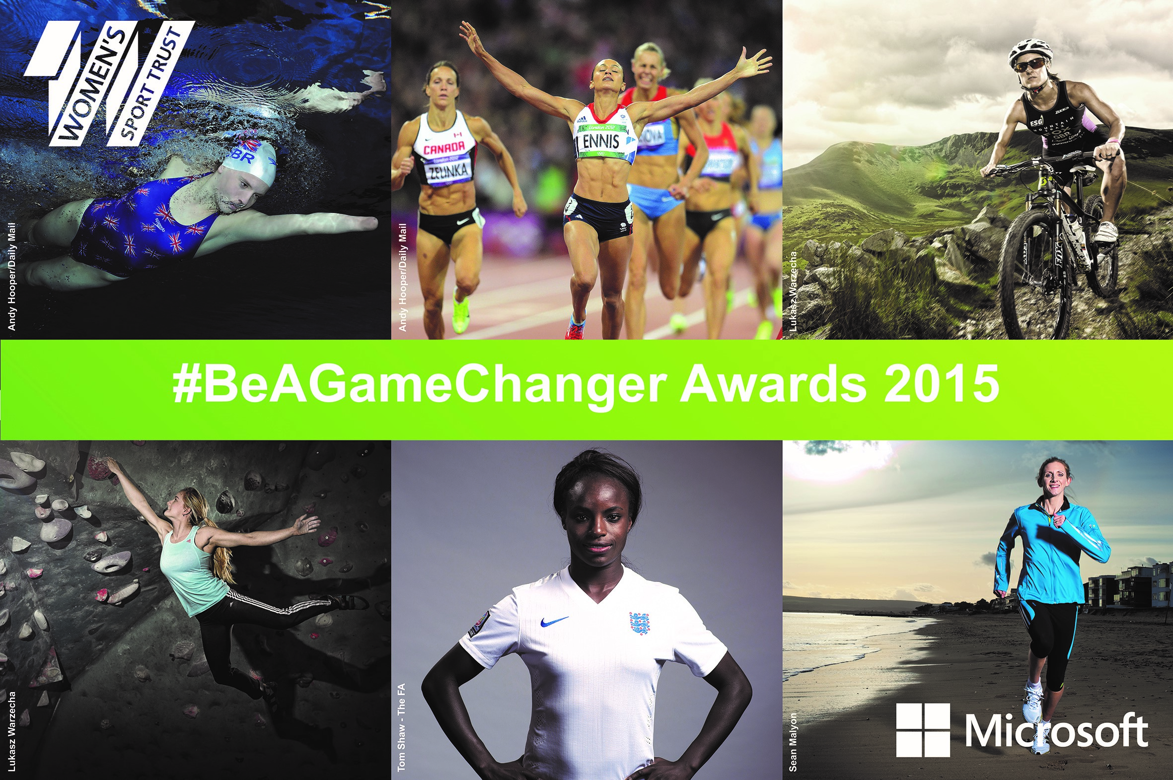
Nomination Form - Sponsorship of the Year

A partnership between sport and business that has resulted in the most exciting new sponsorship in women’s sport. This award recognises the vital role of sponsorship in raising the profile and increasing the impact of women’s sport.

Eligibility | Criteria
- Sponsorship of a UK based team, sport, event or individual .  - Sponsorship that has had a significant impact in the last 12-month period.  - A joint nomination that represents the partnership between sport and business. | Nominees will have:  - Secured a significant investment that has demonstrably changed the circumstances of the team, sport, event or individual involved.  - Raised the profile of women’s sport and generated media coverage.  - Demonstrated long-term thinking that will enable sustainable change.  - Shown creativity and innovation in approach.

About the nomination
Name of person, organisation or initiative being nominated
Click here to enter text.
Tell us in brief about the achievements of the athlete, person, organisation or initiative being nominated.
(max 300 words)
Click here to enter text.
With reference to the specific criteria for this award tell us how the nominee/s has had an impact and been a game changer for women’s sport.
(max 500 words)
Click here to enter text.
If you would like to include any items to support your nomination e.g. website links, images, video, media coverage, or attachments please list them here and attach when emailing your nomination. (max 3) | - Click here to enter text.  - Click here to enter text.  - Click here to enter text.

About you
Your name
Your email address | Click here to enter text.
Your age | ☐Under 14  ☐15-21  ☐22-29  ☐30-39 | ☐40-49  ☐50-59  ☐60-69  ☐70+
Your postcode | Click here to enter text.
Permission to add you to our mailing list? | Yes ☐  No ☐
Do you want to be entered in a draw to win two free tickets to the event on 14th May in London? | Yes ☐  No ☐
Do you agree to our terms and conditions? | Yes☐  No ☐

This form should be emailed to BeAGameChanger@womenssporttrust.com by 16th February 2015.

Terms and Conditions for #BeAGameChanger Awards

Nominations Process
- The nomination process will be open between the 26th January 2015 and 16th February 2015.
- You can nominate yourself, a colleague, a hero, a mentor or even a rival.
- An official form must be completed and submitted via email to beagamechanger@womenssporttrust.com for each nomination. You can nominate more than one person/organisation but a new form is required for each nomination.
- WST will electronically acknowledge receipt of each nomination submitted. If you do not receive an auto respond message, then please contact us via our website.
- WST Trustees and members of the Expert Panel will not be eligible to nominate for / or be nominated for any of the categories.
- Sponsors of the WST #BeAGameChanger Awards cannot be nominated for any of the #BaGC Awards.

Shortlisting Process
- WST Trustees will use the advertised criteria to draw up a shortlist for each of the 7 awards.
- Those on the shortlist may be contacted to clarify the following:
  - Agreement to their application proceeding through the #BAGC shortlisting process
  - Agreement to these Terms and Conditions
  - Agreement that information submitted via this process can be used by WST to promote the #BAGC Awards.
  - For further information to support their application.
- An Expert Panel will use the advertised criteria to identify up to 3 finalists from the shortlist for each award category.
  - The expert panel will comprise representatives from the following professions; business, media, sponsorship, the sports world and athletes.
  - Details of the expert panel will be available on the WST website: www.womenssporttrust.com
  - The expert panel’s decisions on the finalists for each award will be final.
- WST will only contact finalists. If you have not heard from us by the 20th March 2015, then please assume that you have not been successful.

Public Voting & Winner Notification Process
- The winner of each category will be determined by public vote on a shortlist of 3 for each award category.
- The online public voting system will be open from the 7th April to the 19th April 2015
- Winners will be those who receive the most votes in each award category.
- Winners will be contacted around the 20th April 2015.
- Our communications team will support finalists to highlight their achievements in a brief written and visual summary. It is hoped that finalists will be willing, with the support of our communications team, to undertake up to three media interviews.

